**Vapor Compression Refrigeration Case Study**

**Ryan Konon, Nathan Stenseng**

**2021-05-07**

**Dr. Bryan Weber**

| **Nomenclature $\dot{W}$**  Power, kW $\dot{Q}$ Heat Rate, kW $\dot{m}$ Mass Flow Rate, kg/s $p$ Pressure, MPa $T$ Temperature, K $h$ Specific enthalpy, kJ/kg $s$ Specific entropy, kJ/kg/K $x$ Quality $y$ Split Ratio  *Greek Symbols $β$*  Coefficient of Performance | *Subscripts $RS$*  Refrigeration Space $atm$ Atmospheric $air$ Moist Air Mixture $a$ Dry Air $v$ Water Vapor $f$ Saturated Liquid $g$ Saturated Vapor $C$ Compressor $in$ Input |
| --- | --- |

**Introduction:**

Commercial refrigerators are crucial for large scale cooling, employed in restaurants, grocery stores, and hospitals to keep food, vaccines, and medicine from spoiling. However, they are also notoriously good at ramping up energy bills and damaging the ozone layer. With efficiency and environmental consciousness in mind, we will reevaluate and improve upon the design of a vapor-compression refrigeration system. By altering its operating parameters and testing different working fluids, we will improve the cycle's performance and meet more vigorous environmental standards, preserving both money and the environment.

The vapor compression refrigeration cycle operates on four fundamental processes:

1. Isentropic compression
2. Isobaric heat rejection
3. Isenthalpic expansion
4. Isobaric heat addition

To achieve these four processes, the system makes use of a compressor, a condenser, an expansion valve, and an evaporator. Beyond these simple components, our refrigeration system utilizes a dehumidifier to achieve the desired relative humidity in the refrigerator. In general, refrigeration systems cool air by moving heat from a cold reservoir to a hot reservoir. While they all operate on this same general principle, not all systems are created equal. The system we are optimizing continuously cools and pumps new air into the fridge, while releasing the previously cooled air back into the atmosphere. Other, more efficient systems, recirculate the already cooled air, which decreases the initial air temperature. Thus, less work input is required to reach the desired temperature (as the air is “pre-cooled”). With that being said, implementing a recirculating air system into our refrigeration cycle would be costly and change the structure of the cycle entirely. Thus, we will instead optimize what we can in the existing system. Namely, the refrigerant and the temperature difference between reservoirs.

Our system currently uses R-22 and we will be looking at replacing this with either R-134a or ammonia (R-717). While we will analyze the performance of our system with each working fluid, a preliminary analysis of their properties is beneficial. First, it is important to consider each refrigerant’s global warming potential (GWP). This is a measure of the refrigerant’s potential to pollute over a given time period, relative to the reference gas of CO2 (which has a GWP of 1). For R-22, R-134a, and ammonia, we have 100-year GWPs of 1810, 1430, and 0, respectively [1]. In other words, over R-22 is nearly 2000 times more potent to the environment than carbon dioxide, making one pound of R-22 almost equal to one ton of carbon dioxide in its ability to pollute. Hence, we are replacing R-22 with either R-134a or ammonia, both of which are relatively safe to work with. Neither are very flammable and they do not deplete the ozone layer. Beyond its lower GWP, ammonia has some clear advantages. It is less expensive, naturally occuring, and narrower piping can be used to decrease building costs. It also produces a higher coefficient of performance for the cycle, decreasing the required work input [2]. Downsides of ammonia include its incompatibility with copper piping (which many current refrigeration systems use) due to corrosion and its toxicity in high concentrations (though it is easy to recognize an ammonia leak because of its smell). R-134a can not boast the same benefits, though it can be used with copper piping, which is less expensive than steel piping that ammonia requires.

In this report, we will optimize our refrigeration cycle and detail a more numerical analysis of the effect each refrigerant has on the cycle’s performance.

**Methods:**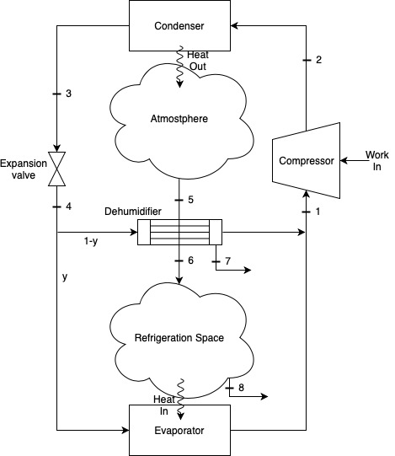

*Figure 1 depicts a schematic of our vapor compression refrigeration cycle with an attached dehumidification unit.*

In this report, we will be studying the vapor compression refrigeration cycle depicted in *Fig. 1.* The refrigeration fluid splits into two mass fractions. The main portion of fluid, *y*, goes towards producing the 80 tons of refrigeration necessary to maintain the cold temperature within the refrigerator. A smaller fraction of fluid, $1-y$, cools and dehumidifies the air flowing from state 5 to state 6, releasing any condensate resulting from this dehumidification at state 7. The cool air (from state 6) circulates through the refrigerator and is then rejected back into the atmosphere.

By the second law of thermodynamics, for heat to flow between the atmosphere (at the condenser) and the refrigerator (at the evaporator), we must have a temperature difference, $ΔT$. We need the refrigeration space to remain at a temperature $T_{RS}$, therefore the fluid that passes through the evaporator must be at a temperature $T_{RS}-ΔT.$ Likewise, fluid flowing through the condenser from state 2 to 3 requires a temperature greater than $T_{atm}+ΔT$ to promote heat transfer. In our model of the system, we assume that the evaporator and condenser function at a constant pressure, and that the expansion valve maintains a constant enthalpy. Using this information and technology, we can fix each state in the basic vapor compression refrigeration cycle using two independent, intensive properties, as outlined in *Table 1* [3]*.*

| **State** | **Property 1** | **Property 2** |
| --- | --- | --- |
| 1 | $T_{RS}-ΔT$ | $x_{g}$ |
| 2s | $p_{3}$ | $s_{1}$ |
| 2 | $p_{3}$ | $h_{2}$ |
| 3 | $T_{atm}+ΔT$ | $x_{f}$ |
| 4 | $p_{1}$ | $h_{3}$ |

*Table 1 lists the properties required to fix each state in our vapor compression cycle*

The mass flow rate required to cool our refrigerator space, $\dot{m}y$ is:

$\dot{m}y=\frac{{\dot{Q}}_{in}}{h_{1}-h_{4}}$ eq.(1)

Where ${\dot{Q}}_{in}$ is the amount of heat we need to remove from our refrigeration space. Similarly, the mass flow rate required to cool and dehumidify our air is defined as follows:

$\dot{m}(1-y)=\frac{{\dot{Q}}_{air}}{h_{1}-h_{4}}$ eq.(2)

where ${\dot{Q}}_{air}$ is the heat required to dehumidify and cool 400 ft3/min of atmospheric air that we pump into the refrigerator. To find ${\dot{Q}}_{air},$ we can write an energy rate balance for the system around the dehumidifier:

${\dot{Q}}_{air}={-\dot{m}}_{a}h_{a(atm)}-{\dot{m}}_{v(atm)}h_{v(atm)}+{\dot{m}}_{a}h_{a(RS)}+{\dot{m}}_{v(RS)}h_{v(RS)}+{\dot{m}}_{w}h_{w}$ eq.(3)

As for regulating the humidity of the air in our refrigerator, we can calculate the specific enthalpies of the water vapor and dry air (both components of the moist air) after fixing their states with their pressure and temperature. We can use the relative humidity of the moist air to find the partial pressure of the water vapor.

$p_{v}=\frac{p_{g}}{ϕ}$ eq.(4)

Assuming the total moist air mixture is at atmospheric pressure, we can subtract the water vapor partial pressure from atmospheric pressure to find the partial pressure of dry air.

$p_{a}=1 atm -p_{v}$ eq.(5)

With these values determined, we can solve for various metrics associated with the dehumidifier in our refrigeration system.

To measure the efficiency of our refrigeration system, we can calculate the coefficient of performance, $β$. With that, to gauge the system’s feasibility, we will also look at and optimize the system’s operating pressures, work input, and mass flow rate. The total mass flow rate of the system is simply the summation of the mass flow rates for the refrigeration line (*y*) and the dehumidification line (*1-y*), given by eq.(1) and eq.(2), respectively. The work input of the compressor is governed by:

${\dot{W}}_{c}=\dot{m}(h_{1}-h_{2})$ eq.(6)

where $h_{2}$ is determined by the thermal efficiency of the compressor:

$h_{2}=\frac{h_{2s}-h_{1}}{η_{c}}+h_{1}$ eq.(7)

Finally, the coefficient of performance for our refrigeration cycle is:

$β=\frac{{\dot{Q }}_{in}+{\dot{Q}}_{air}}{|{\dot{W}}_{C}|}$ eq.(8)

**Results and Discussion:**

For our design of a vapor compression refrigeration cycle, we have the following constraints and initial conditions:

| **Location** | **Temperature (℃)** | **Relative Humidity (%)** | **Heat Input (Tons of Refrigeration)** |
| --- | --- | --- | --- |
| Internal Air | 8 | 47 | 80 |
| External Air | 27 | 63 | -- |

*Table 2 displays the conditions at which our system must operate. Note, the internal air represents the inside of the refrigerator, the external air represents the atmospheric air being 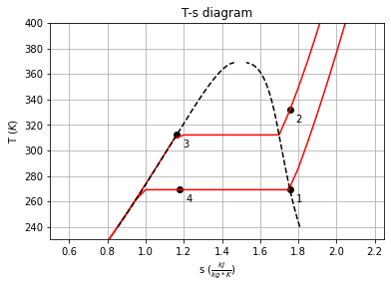taken into, and cooled by, our system, and the heat input is the required amount of refrigeration.*

*Figure 2 depicts the T-s diagram for our cycle according to our initial design parameters with a $ΔT$ of $12^{o}C.$*

Using the information in *Tables 1* and *2*, we can set the first four states (*Fig 2*), as well as the dehumidifier states using Thermostate and the equations defined in the methods section. With all the initial conditions, and with the original working fluid (R-22), our cycle achieves a coefficient of performance (*ꞵ*) of 5.04. However, replacing R-22 with R-134a changes the coefficient of performance to 4.98, and using ammonia brings it even higher, to 5.25. With that being said, changing the refrigerant used in our vapor compression cycle changes a number of properties. Key changes are outlined in *Table 3*.

| **Refrigerant** | **COP**  **(dimensionless)** | **Work in**  **(kJ/s)** | **Operating pressure**  **(atm)** | **Mass flow rate**  **(kg/s)** | **Cost**  **($/kg)** |
| --- | --- | --- | --- | --- | --- |
| R-22 | 5.04 | 57.87 | 4.31  14.77 | 1.88 | 265.00 |
| R-134a | 4.98 | 58.6 | 2.49  9.77 | 2.06 | 75.00 |
| Ammonia | 5.25 | 55.58 | 3.64  14.92 | 0.27 | 20.00 |

*Table 3 outlines operating properties to consider for each working fluid [4][5]. Note, the lower operating pressure for each fluid is at states 4-1, and the upper is at states 2-3.*

We will also look at the performance of refrigerants with other initial conditions. Varying the temperature difference between reservoirs greatly changes the necessary mass flow rate to cool the refrigeration space, therefore increasing the amount of compressive work done. In turn, the coefficient of performance changes, depicted in *Fig 3*.

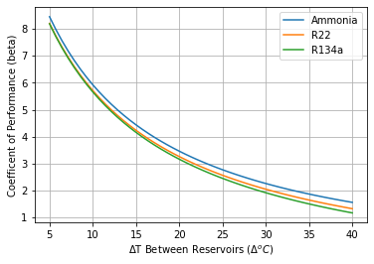

*Figure 3 shows how the system's coefficient of performance changes for varying differences between the temperatures of our system and our reservoirs.*

Our other main assumption is that atmospheric air has a constant temperature and relative humidity. In reality, the atmospheric air changes daily. For different times of year, our coefficient of performance can change drastically, as demonstrated by *Fig 4.*

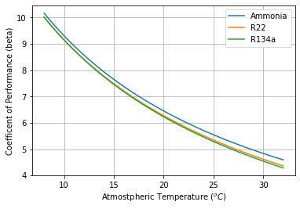

*Figure 4 depicts the coefficient of performance of our cycle for varying atmospheric air temperatures.*

The temperature of atmospheric air plays a significant role in the efficiency of our vapor compression refrigerator in two ways. For one, it serves as our hot reservoir. In order to reject heat from our system, the working fluid must be $12^{o}C$ hotter than the atmosphere to allow for energy transfer. If the hot reservoir is warmer, we must compress the working fluid more to maintain an appropriate temperature difference. And two, our dehumidification system needs to cool and dehumidify the atmospheric air before it enters the refrigeration space. If the atmospheric air is initially hotter, it will require more refrigerant to cool. And more refrigerant demands more compressive work, further decreasing our systems thermal efficiency (shown in *Fig.* 5).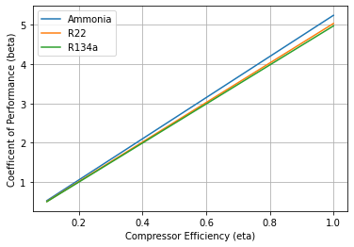

*Figure 5 graphs the coefficient of performance of our cycle over different compressor efficiencies.*

Per what we just discussed, a larger mass flow rate affects the compressor work (as eq.(6) reflects), but this metric is also influenced by the compressor’s efficiency (described by eq.(7)). Our initial calculations assumed a perfectly efficient compressor, but realistically this is not achievable. *Fig. 5* depicts how worse compressor efficiencies lower the coefficient of performance with different working fluids. Most notably, with low compressor efficiencies, the difference in the coefficient of performance between the three fluids decreases. This means that, when using low efficiency compressors, the working fluid we choose becomes less important. Referencing *Table 3*, we conclude that for a cheap but less efficient compressor, R-134a is situationally more favorable than ammonia because it can be used at drastically lower pressures (although the COP is slightly lower). That being said, modern compressors operate at efficiencies in the range of 70 to 85 percent [7]. Therefore, unless the system is old and utilizing a less efficient compressor, ammonia is the favorable working fluid in terms of efficiency.

**Conclusion:**

We have designed and optimized a vapor compression refrigeration system that, based on the given design constraints (using R-22), achieves a coefficient of performance of 5.04, requires a work input of 57.87 kJ/s, and operates with a mass flow rate of 1.88 kg/s. For environmental purposes (and evidently efficiency purposes), we will replace the R-22 with ammonia, improving all five metrics outlined in *Table 3*. With ammonia, the cycle achieves a coefficient of performance of 5.25, requires a work input of 55.58 kJ/s, and operates with a mass flow rate of 0.27 kg/s (it can also be used at lower pressures). Ammonia outperforms the other two synthetic refrigerants for varying temperature differences between the reservoirs and at different atmospheric temperatures. It can also operate with a much lower mass flow rate, though we do note R-134a can operate at lower pressures. Despite this, ammonia is better for the environment and improves nearly all the important metrics associated with a vapor compression refrigeration cycle. Thus, we recommend ammonia as the new refrigerant employed in our system.

As for the system itself, decreasing the temperature difference between the reservoirs improves the cycle’s performance. In our case, the design parameters restrict lowering the difference below 12*℃*, and we therefore recommend the difference to be exactly 12*℃*. In terms of construction, we will have to invest in steel pipes so that ammonia does not corrode the current copper pipes. Luckily, though steel is more expensive, ammonia does not require large diameter pipes. Converting the working fluid to ammonia and making the associated changes to the system improves the cycle performance, meets more vigorous environmental standards, and ultimately saves money.

**References:**

1. *California Air Resources Board*. High-GWP Refrigerants | California Air Resources Board. (n.d.). https://ww2.arb.ca.gov/resources/documents/high-gwp-refrigerants#:~:text=The%20most%20common%20refrigerant%20today,a%20ton%20of%20carbon%20dioxide
2. *Comparison between refrigerants (ammonia vs freon)*. Agility Engineering Malaysia. (n.d.). https://agilityrefrigeration.weebly.com/information/comparison-between-refrigerants-ammonia-vs-freon.
3. B. Weber, “Thermostate: A state manager for thermodynamics courses,” University of Connecticut, 2018, <https://github.com/bryanwweber/thermostate/>
4. *Serve Pty Ltd*. Cool. http://www.cool-serve.com.au/service.html.
5. Price conversions and cost calculator for materials and substances. (n.d.). https://www.aqua-calc.com/calculate/materials-price.
6. Lene Fjerbaek Sotoft, Michael B. Pryds, Anne Kjærhuus Nielsen, Birgir Norddahl, Process Simulation of Ammonia Recovery from Biogas Digestate by Air Stripping with Reduced Chemical Consumption., Editor(s): Krist V. Gernaey, Jakob K. Huusom, Rafiqul Gani, Computer Aided Chemical Engineering, Elsevier, Volume 37 , 2015, Pages 2465-2470,ISSN 1570-7946, ISBN 9780444634290,<https://doi.org/10.1016/B978-0-444-63576-1.50105-9>.